Academic Year: 2025-26 | Year: Second Year | Semester: II
PRN No.: 1012411011 | Name: Riddhee Kulkarni
Subject: Python Programming
Assignment No.: 9
Date: 05/01/2026

Lab Assignment: 09
Aim:
To write a Python program to find the greatest of three numbers entered by the user.

Objective:
To compare three numbers using conditional statements and display the greatest number.

Theory:
Conditional statements (if, elif, else) are used in Python to execute different blocks of code based on conditions.
By comparing three numbers using relational and logical operators, we can determine the greatest among them.

Algorithm:
- Start
- Read three numbers from the user
- If first number is greater than the other two, print first number
- Else if second number is greater than the other two, print second number
- Else print third number
- Stop

Pseudo Code:
START
READ num1, num2, num3
IF num1 > num2 AND num1 > num3
PRINT "1st number is greatest"
ELSE IF num2 > num1 AND num2 > num3
PRINT "2nd number is greatest"
ELSE
PRINT "3rd number is greatest"
END IF
STOP

Code:
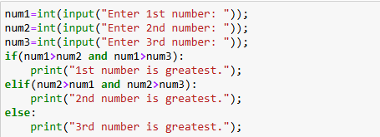

Output:
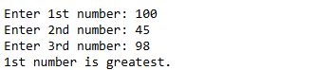
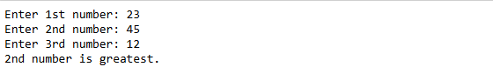
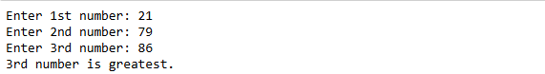

Conclusion:
The program successfully compares three numbers and displays the greatest among them using conditional statements.

